Image Analysis of Early Exploration
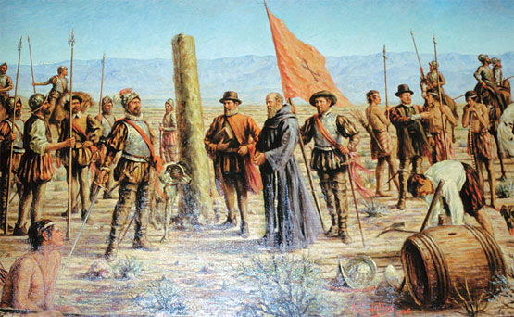
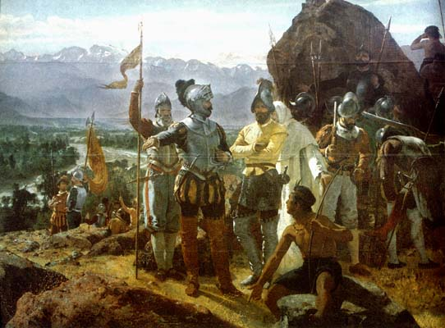
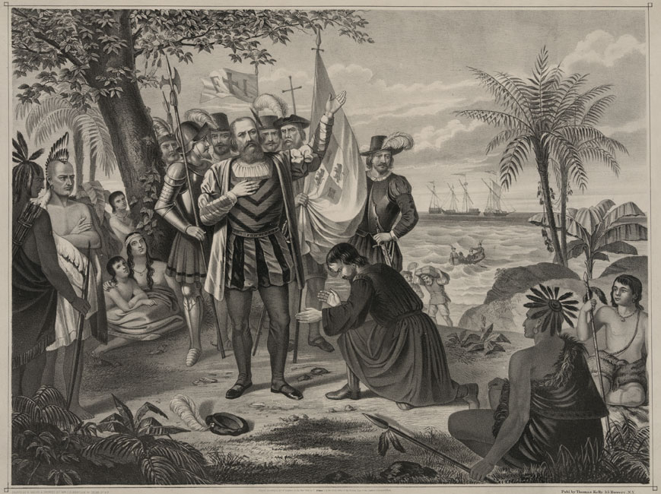

Follow-Up Questions:

Describe three similarities between these images:

How would you describe the attitude of these images?

What role do Native Americans play in these images?

What role does religion play in these images?

Describe three examples of bias in these images:

