Wake County Public School System
Social Studies Benchmark
Grade 8

Units 10-12

Grade 8 Benchmark: Units 10 - 12

Excerpt from Khrushchev’s letter to the White House, sent on October 27, 1962:

“You are disturbed over Cuba. You say that this disturbs you because it is ninety miles by sea from the coast of the United States of America. But. . . you have placed destructive missile weapons, which you call offensive, in Turkey, literally next to us. . .

I therefore make this proposal: We are willing to remove from Cuba the means which you regard as offensive...Your representatives will make a declaration to the effect that the United States...will remove its analogous means from Turkey. . . . And after that, persons entrusted by the United Nations Security Council could inspect on the spot the fulfillment of the pledges made. . . .”

Excerpt from John F. Kennedy’s comments in response to the above letter during a meeting of EX-COMM (a group of 12 of Kennedy’s top advisers assembled to handle the Cuban Missile Crisis):

“He's (Khrushchev) got us in a pretty good spot here, because most people will regard this (the new letter) as not an unreasonable proposal, I'll just tell you that. In fact, in many ways-- I think you're going to find it very difficult to explain why we are going to take hostile military action in Cuba against these sites--what we've been thinking about--the thing that he's saying is, 'If you'll get yours out of Turkey, we'll get ours out of Cuba.'...We can't very well invade Cuba with all its toll when we could have gotten the missiles out by making a deal on the same missiles in Turkey. If that's part of the record I don't see how we'll have a very good war.”

- Based on the above prompts, why were President Kennedy and the U.S. concerned about Russia moving missiles to the island of Cuba? (8.H.1.5, 8.G.1.1)
- Cuba was only 90 miles south of the United States.
- Cuba was an unstable enemy of the United States.
- The missiles could cause pollution if not stored properly.
- Kennedy wanted to store the missiles on U.S. soil.

- Which of the following most likely expresses the sentiment (feelings) shared by both Khrushchev and Kennedy? (8.H.1.5, 8.H.2.2)
- Both were afraid to use or give up access to their missiles.
- Both men were excited to use the destructive missiles.
- Each wanted to see who could create the most destructive missiles.
- Each wanted to learn to use the missiles before the other had the chance.

- What was President Kennedy’s purpose in his response? (8.H.2.3)
- To convince Congress that we must declare war on the Russians.
- To prove that Russia was taking advantage of trade relations with Cuba.
- To show that the U.S. had to take a reasonable approach with the Russians.
- To make himself appear sympathetic to the Russians and gain their respect.

Source 1- President John F. Kennedy explains the quarantine on Cuba:

“It shall be the policy of this nation to regard any nuclear missile launched from Cuba against any nation in the Western Hemisphere as an attack by the Soviet Union on the United States, requiring a full retaliatory response upon the Soviet Union. To halt this offensive buildup, a strict quarantine [restriction] on all offensive military equipment under shipment to Cuba is being initiated. All ships of any kind bound for Cuba, from whatever nation or port, will, if found to contain cargoes of offensive weapons, be turned back. This quarantine will be extended, if needed, to other types of cargo and carriers. We are not at this time, however, denying the necessities of life as the Soviets attempted to do in their Berlin blockade of 1948.”

Source 2- Whitehouse.gov background information regarding President Obama’s policy toward Iran:

In July 2012, the Obama Administration took two actions to further isolate and penalize Iran for its refusal to live up to its international obligations regarding its nuclear program, and to hold accountable financial institutions that knowingly provide financial services to Iranian banks that are under U.S. sanctions for their connection to illicit [illegal] activities. These steps are part of President Obama’s commitment to prevent Iran from acquiring nuclear weapons by raising the cost of Iran’s defiance of the international community.

- What is purpose of the first line of Kennedy’s address in Source 1? (8.H.1.2)
- To warn the Russians of the consequences of launching missiles from Cuba.
- To inform Americans that Russians are planning offensive attacks from Cuba.
- To empower American citizens to join the military and help protect the country.
- To convince the Russian people that the Cuba does not want any more missiles.

- According to Kennedy, what was the purpose of the quarantine? (8.H.1.5)
- To prevent any more missiles from coming into Cuba.
- To reward the Cuban people for their cooperation.
- To punish the Russians for launching missiles in Cuba.
- To encourage increased trade between the US and Cuba.

- What does President Obama’s response to the Iranians have in common with the Cuban Missile Crisis and the Cold War? (8.H.3.4)
- Both encourage increased trade with the United States.
- Both reward individuals from foreign nations for their cooperation.
- Both are designed to stop the spread of communism.
- Both are designed to stop the spread of nuclear weapons.

Source 1:

Source 2: Presidential Election Results, 1964
Presidential candidate | Party | Popular vote |  | Electoral  vote
 |  | Count | Pct
Lyndon B Johnson | Democratic | 43,127,041 | 61.1% | 486
Barry M Goldwater | Republican | 27,175,754 | 38.5% | 52
Source 4: Excerpt from Richard Nixon’s Address Accepting the Presidential Nomination at the Republican National Convention in Miami Beach, Florida August 8, 1968

“For four years this Administration has had at its disposal the greatest military and economic advantage that one nation has ever had over another in any war in history.

For four years, America's fighting men have set a record for courage and sacrifice unsurpassed in our history…

Never has so much military and economic and diplomatic power been used so ineffectively.

And if after all of this time and all of this sacrifice and all of this support there is still no end in sight, then I say the time has come for the American people to turn to new leadership -- not tied to the mistakes and the policies of the past. That is what we offer to America.

And I pledge to you tonight that the first priority foreign policy objective of our next Administration will be to bring an honorable end to the war in Vietnam. We shall not stop there -- we need a policy to prevent more Vietnams.”
Source 3: Presidential Election Results, 1968
Presidential candidate | Party | Popular vote |  | Electoral  vote
 |  | Count | Pct
Richard M Nixon | Republican | 31,783,783 | 43.4% | 301
Hubert H Humphrey | Democratic | 31,271,839 | 42.7% | 191

- In Source 4, what does Nixon accuse Johnson of doing wrong? (8.H.2.3, 8.H.2.1)
- Ending the Vietnam War early and without honor.
- Ignoring the sacrifices made by the U.S. military.
- Failing to prevent the Vietnam War from ever starting.
- Misusing or wasting military and economic resources.

- What did Nixon promise to do if he was elected president? (8.H.1.3, 8.H.2.2)
- End the war in Vietnam and prevent future, similar conflicts.
- Use military and economic resources more efficiently in Vietnam.
- Reward American soldiers for their courage and sacrifice.
- Continue fighting the enemy in North Vietnam at all costs.

- How did Nixon handle Vietnam once he was elected President? (8.H.2.2)
- He increased the number of troops sent to Vietnam.
- He took all of the troops out of Vietnam immediately.
- He gradually began to remove U.S. troops from Vietnam.
- He did not change the number of U.S. troops in Vietnam.

- Based on the sources above, how did the majority of Republicans feel about the war in Vietnam by the time Richard Nixon ran for office in 1968? (8.C&G.1.1)
- People were furious with Nixon for wanting to leave Vietnam so soon.
- People were frustrated and wanted to end U.S. involvement in the war.
- People were excited to continue the war and fight for communism.
- People were supportive of the efforts made by the military in Vietnam.

- Based on both charts in Source 2 and 3, which political party benefitted from Johnson’s policies in Vietnam? (8.C&G.1.1)
- The Republican Party
- The Democratic Party
- Both Parties
- Neither Party

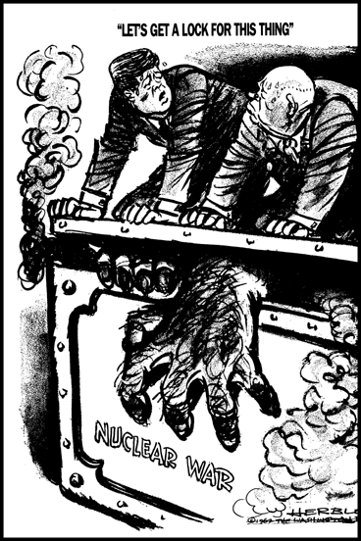
President John F. Kennedy made public the presence of Soviet missiles in Cuba in this speech to the American people.
October 22, 1962
I call upon Chairman Khrushchev to halt and eliminate this clandestine [secret], reckless, and provocative threat to world peace and to stable relations between our two nations. I call upon him further to abandon this course of world domination, and to join in an historic effort to end the perilous arms race and to transform the history of man. He has an opportunity now to move the world back from the abyss [deep hole] of destruction -- by returning to his government's own words that it had no need to station missiles outside its own territory, and withdrawing these weapons from Cuba -- by refraining from any action which will widen or deepen the present crisis -- and then by participating in a search for peaceful and permanent solutions. ...
My fellow citizens: let no one doubt that this is a difficult and dangerous effort on which we have set out. No one can foresee precisely what course it will take or what costs or casualties will be incurred… But the greatest danger of all would be to do nothing. ...

- What did President Kennedy want Chairman Khruschev to do?
- Arm more countries outside of the USSR.
- Become the leader of the whole world.
- Withdraw nuclear weapons from Hawaii.
- End the threat of world destruction.

- In the cartoon, what are President Kennedy and Chairman Krushev doing?
- Trying to capture a destructive monster
- Trying to stop a nuclear war from occurring
- Trying to allow nuclear weapons to be created
- Trying to put out a large, dangerous fire

- What would be the greatest danger, according to President Kennedy?
- To end the arms race
- To work with USSR to get along
- To do absolutely nothing
- To build up more missile sites

North Atlantic Treaty
Washington, D.C.
April 4, 1949

Article 5
The Parties agree that an armed attack against one or more of them in Europe or North America shall be considered an attack against them all…

Any such armed attack and all measures taken as a result thereof shall immediately be reported to the Security Council. Such measures shall be terminated when the Security Council has taken the measures necessary to restore and maintain international peace and security.

Article 6
For the purpose of Article 5, an armed attack on one or more of the Parties is deemed to include an armed attack:

- On the territory of any of the Parties in Europe or North America, on the Algerian Departments of France, on the territory of Turkey or on the islands under the jurisdiction of any of the Parties in the North Atlantic area north of the Tropic of Cancer;
- On the forces, vessels, or aircraft of any of the Parties, when in or over these territories or any area in Europe in which occupation forces of any of the Parties were stationed on the date when the Treaty entered into force or the Mediterranean Sea or the North Atlantic area north of the Tropic of Cancer.

- What does the Treaty state will happen if one member country is attacked?
- They will have to fight all alone.
- Other countries will defend them.
- They will need to surrender at once.
- Others will expel them from NATO.

- Which area was covered in the Treaty?
- Turkey
- Pakistan
- Brazil
- China

- When will attacks be considered to be finished?
- When the USSR has control of Europe.
- When the USA has control of the USSR.
- When peace and security are restored.
- When parties are armed and ready to fight.

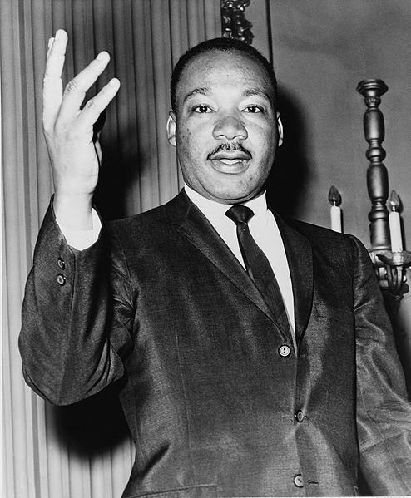
“Letter From Birmingham Jail” April 16, 1963

Moreover, I am cognizant of the interrelatedness of all communities
and states. I cannot sit idly by in Atlanta and not be concerned about
what happens in Birmingham. Injustice anywhere is a threat to justice
everywhere. We are caught in an inescapable network of mutuality,
tied in a single garment of destiny. Whatever affects one directly,
affects all indirectly. Never again can we afford to live with the narrow,
provincial "outside agitator" idea. Anyone who lives inside the United
States can never be considered an outsider anywhere within its bounds.
You deplore the demonstrations taking place in Birmingham. But your statement, I am sorry to say, fails to express a similar concern for the conditions that brought about the demonstrations. I am sure that none of you would want to rest content with the superficial kind of social analysis that deals merely with effects and does not grapple with underlying causes. It is unfortunate that demonstrations are taking place in Birmingham, but it is even more unfortunate that the city's white power structure left the Negro community with no alternative.
In any nonviolent campaign there are four basic steps: collection of the facts to determine whether injustices exist; negotiation; self-purification; and direct action. We have gone through all of these steps in Birmingham. There can be no gainsaying the fact that racial injustice engulfs this community. Birmingham is probably the most thoroughly segregated city in the United States. Its ugly record of brutality is widely known. Negroes have experienced grossly unjust treatment in the courts. There have been more unsolved bombings of Negro homes and churches in Birmingham than in any other city in the nation. These are the hard, brutal facts of the case. On the basis of these conditions, Negro leaders sought to negotiate with the city fathers. But the latter consistently refused to engage in good-faith negotiation.

- What injustice is Dr. King referring to in this letter?
- Racism
- Unemployment
- Slavery
- Homelessness

- What was going on in Birmingham that Dr. King was trying to fix?
- bombing of Native American homes
- brutality towards African Americans
- segregation against white people
- unjust treatment against women

- Which of the following tactics would King oppose?
- Collection of facts
- Negotiation
- Direct action
- Armed response

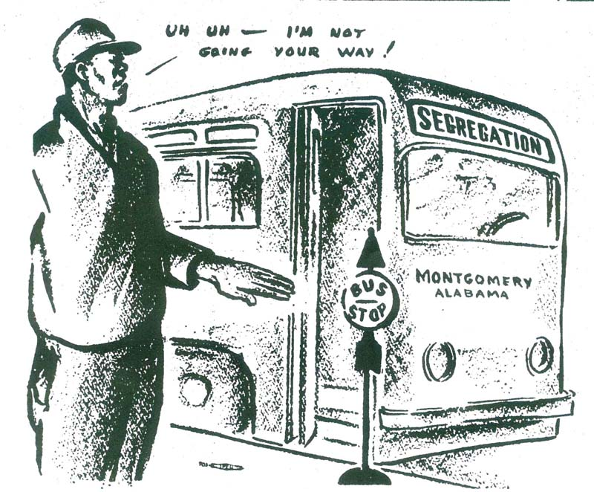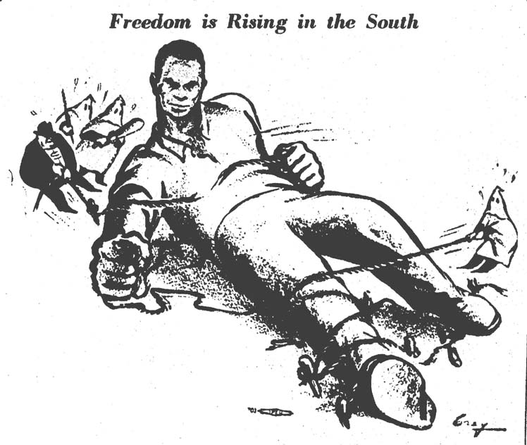

- What do the central figures in the cartoons symbolize?
- The burden of being forced to follow the rules
- The struggle of a community against racism
- The shame of being caught committing a crime
- The obedience of listening to the men talking

- Who is trying to hold the man down in the cartoon on the right?
- Women
- Ku Klux Klan
- Black men
- Schools

- The action of the man in the cartoon on the left can best be described as a:
- sit in
- boycott
- freedom ride
- hunger strike
The Watergate Scandal refers to a series of events that occurred between 1972 and 1974. The scandal got its name from the burglary at the headquarters of the Democratic National Committee in the Watergate Hotel Complex in Washington, D.C.

Evidence found on one of the burglars implied a possible link to the White House and prompted an investigation. Over the next two years, the political links were found to reach increasingly higher up the power chain. The unlawful acts were committed on behalf of the Committee to Re-elect the President (CRP), which was later referred to as CREEP.

The reputations of many politicians were tarnished by the scandal, which ultimately resulted in the resignation of President Richard Nixon.

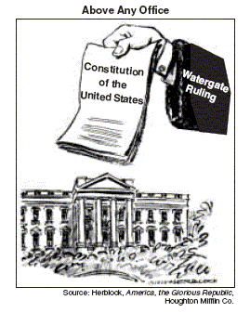
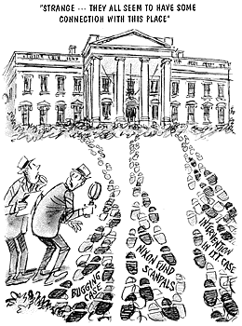

Watergate Scandal
Nixon Fund Scandal

Bugging
Case

- What is the intended meaning of the cartoon on the right?
- The Whitehouse has no power.
- The President is not above the law.
- Watergate never happened.
- Constitution and President are equal.

- The cartoon on the left implies that the President is connected to:
- the Vietnam War.
- respectable policies.
- questionable activities.
- a bug infestation.

Statement on September 11, 2001 by United States President George W. Bush after a terrorist attack on the World Trade Center, the Pentagon, and other sites.

Immediately following the first attack, I implemented our government's emergency response plans. Our military is powerful, and it's prepared. Our emergency teams are working in New York City and Washington D.C. to help with local rescue efforts. Our first priority is to get help to those who have been injured, and to take every precaution to protect our citizens at home and around the world from further attacks. The functions of our government continue without interruption. Federal agencies in Washington which had to be evacuated today are reopening for essential personnel tonight and will be open for business tomorrow. Our financial institutions remain strong, and the American economy will be open for business as well.

The search is underway for those who were behind these evil acts. I have directed the full resources of our intelligence and law enforcement communities to find those responsible and to bring them to justice. We will make no distinction between the terrorists who committed these acts and those who harbor them.

Statement on October 7, 2001 by United States President George W. Bush after the start of U.S. and British military strikes on targets in Afghanistan.

“On my orders, the United States military has begun strikes against al-Qaeda terrorist training camps and military installations of the Taliban regime in Afghanistan . . . We are supported by the collective will of the world. More than two weeks ago, I gave Taliban leaders a series of clear and specific demands: Close terrorist training camps. Hand over leaders of the al-Qaeda network, and return all foreign nationals, including American citizens unjustly detained in our country. None of these demands were met. And now, the Taliban will pay a price. By destroying camps and disrupting communications, we will make it more difficult for the terror network to train new recruits and coordinate their evil plans . . . Our military action is also designed to clear the way for sustained, comprehensive and relentless operations to drive them out and bring them to justice. At the same time, the oppressed people of Afghanistan will know the generosity of America and our allies. As we strike military targets, we will also drop food, medicine and supplies to the starving and suffering men and women and children of Afghanistan.”

- In both excerpts, to whom is President Bush speaking?
- The Taliban
- Al-Queda
- Americans
- Other nation

- What demands did President Bush make on Taliban leaders?
- Begin strikes on al-Queda terrorist training camps
- Pay to repair the damages from September 11
- Close al-Queda camps and turn over their leaders
- Provide food, medicine, and supplies to the poor

Excerpt from a speech given by Presidential Candidate Barack Obama in March 2008:

“We the people, in order to form a more perfect union.”

Two hundred and twenty-one years ago, in a hall that still stands across the street, a group of men gathered and, with these simple words, launched America's improbable experiment in democracy…

…The document they produced was eventually signed but ultimately unfinished. It was stained by this nation's original sin of slavery, a question that divided the colonies and brought the convention to a stalemate until the founders chose to allow the slave trade to continue for at least twenty more years, and to leave any final resolution to future generations…

…And yet words on a parchment would not be enough to deliver slaves from bondage, or provide men and women of every color and creed their full rights and obligations as citizens of the United States. What would be needed were Americans in successive generations who were willing to do their part—through protests and struggle, on the streets and in the courts, through a civil war and civil disobedience and always at great risk—to narrow that gap between the promise of our ideals and the reality of their time…
…This was one of the tasks we set forth at the beginning of this campaign—to continue the long march of those who came before us, a march for a more just, more equal, more free, more caring and more prosperous America. I chose to run for the presidency at this moment in history because I believe deeply that we cannot solve the challenges of our time unless we solve them together—unless we perfect our union by understanding that we may have different stories, but we hold common hopes; that we may not look the same and we may not have come from the same place, but we all want to move in the same direction—towards a better future for our children and our grandchildren.

- What document is Obama referring to in this speech?
- Magna Carta
- U.S. Constitution
- Articles of Confederation
- Declaration of Independence

- According to President Obama, in addition to words on a paper, what else had to be done to give all people their rights?
- Segregate schools
- Fight a civil war
- Ban equal rights for all
- Forget slavery existed

- How does President Obama propose that we solve the challenges of our time?
- Focus on our similarities
- Work independently
- Fight another civil war
- Forget about the past
Answer Key
- A 8.H.1.5
- B 8.H.2.2
- C 8.H.2.3
- A 8.H.1.2
- A 8.H.1.5
- D 8.H.3.4
- D 8.H.2.3
- A 8.H.2.2
- C 8.H.2.2
- B 8.C&G.1.1
- B 8.C&G.1.1
- D 8.H.2.1
- B 8.H.2.1
- C 8.H.3.2
- B 8.H.2.1
- D 8.H.2.1
- C 8.H.2.1
- A 8.C&G.2.2
- B 8.C&G.2.2
- D 8.C&G.2.1
- B 8.C&.2.2
- B 8.C&G.2.2
- B 8.C&G.2.1
- B 8.C&G.1.1
- C 8.C&G.1.1
- B 8.H.2.1
- C 8.H.2.1
- B 8.C&G.1.3
- B 8.C&G.1.3
- A 8.C&G.1.3

