2013 – 2014
8th Grade Test Bank
Units 4-6

1) Which governmental action illustrates the system of checks and balances?
- a senator helping a governor solve a state problem
- the president negotiating a trade agreement with foreign diplomats
- the Senate ratifying a peace treaty
- Congress raising taxes to pay for federal programs

2) In general, the writers of the Constitution believed that…
- the executive branch should be the strongest component of the federal government.
- political parties were necessary for the fair election of government officials.
- the Constitution contained the most democratic ideals of the Declaration of Independence.
- the new republic would be stable because the majority of the public agreed on important policy issues.

3) After the Revolutionary War, many Americans feared a strong central government. This is best shown by the…
- lack of debate over the ratification of the United States Constitution.
- plan of government set up by the Articles of Confederation.
- development of a Federal court system established to enforce laws.
- constitutional provision calling for a strong Executive Branch.

4) Which part of the US Government is most directly responsible for representing the will of the people?
- Senate
- House of Representatives
- Supreme Court
- Presidency

5) A strict interpretation of the Constitution could have prevented President Jefferson from…
- making the Louisiana Purchase.
- writing “State of the Union” messages.
- receiving ambassadors.
- commissioning military officers.

6) Unlike the Articles of Confederation, the Constitution…
- created a national government having three branches.
- provided for the direct election of the President by the voters.
- made the amendment process more difficult.
- increased the powers of the states.

7) Opponents of the Constitution complained that governing power was concentrated in the…
- State legislatures.
- President’s Cabinet.
- delegates to the Constitutional Convention.
- National Government.

8) A person cannot serve in both the Congress and the judicial branch at the same time. This is an example of…
- limited terms for Federal officials.
- judicial review.
- separation of powers.
- States’ rights.

9) Of the following, the event that best demonstrates the system of checks and balances is:
- President Washington used the army to suppress a tax rebellion by Pennsylvania farmers
- South Carolina seceded from the Union over the issues of slavery and States’ rights.
- President Eisenhower sent Federal troops to enforce desegregation of public schools in Arkansas.
- The Senate approved the appointment of Justice Clarence Thomas to the Supreme Court.

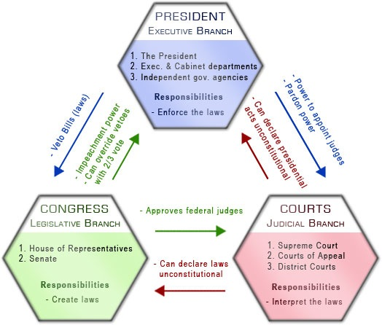

10) Based on the chart, what is the main responsibility of the Judicial Branch?
- To interpret laws and make sure they are constitutional.
- To create laws for the other two branches to follow.
- To help Congress and the President create laws.
- To appoint, approve and pardon federal judges.

11) By definition, a republican form of government is one in which:
- there are two political parties
- representatives are elected by the people
- elected officials have limited terms
- government power is limited by checks and balances

12) The Supreme Court has the power to…
- control the federal budget.
- vote to end a tie in the Senate.
- approve presidential appointments.
- interpret the Constitution.

13) The first amendment of the Constitution deals primarily with…
- states’ rights.
- property rights.
- rights of the accused.
- rights of self-expression.

14) Alexander Hamilton’s financial plan included…
- providing for the payment of the nation’s debts.
- taxing only the people most able to pay.
- favoring agriculture over industry.
- encouraging spending for national defense.

15) Alexander Hamilton proposed a national bank in order to…
- improve the economic position of the United States government.
- help state governments collect taxes.
- make loans available to owners of small farms.
- reduce foreign investment in the United States.

16) President Washington kept the United States out of foreign wars because he believed that…
- the United States needed time to gain economic and military strength.
- treaties were prohibited by the Constitution.
- the United States should not expand by force.
- alliances should be established with both France and England.

Federalist Papers #13: Advantage of the Union in Respect to Economy in Government
For the Independent Journal. Author: Alexander Hamilton

“As CONNECTED with the subject of revenue, we may with propriety consider that of economy. The money saved from one object may be usefully applied to another, and there will be so much the less to be drawn from the pockets of the people. If the States are united under one government, there will be but one national civil list to support; if they are divided into several confederacies, there will be as many different national civil lists to be provided for--and each of them, as to the principal departments, coextensive [overlapping] with that which would be necessary for a government of the whole. The entire separation of the States into thirteen unconnected sovereignties is a project too extravagant and too replete [stuffed] with danger to have many advocates.”

17) According to Hamilton, what was the benefit of this style of government?
- Unifying the government as one would save the taxpayers money.
- Dividing the colonies would protect citizens from excess spending.
- Applying government savings to other objects would please citizens.
- Connecting with subjects would encourage them to think economically.

18) What does Hamilton say might happen if the 13 colonies became “unconnected sovereignties”?
- Money would be wasted because expenses would overlap.
- Money would be saved because expenses would overlap.
- Projects would never be completed due to a lack of funding.
- Projects would be completed quickly due to extra funding.

An Ordinance for the government of the Territory of the United States northwest of the River Ohio.
Section 14: Article 6. There shall be neither slavery nor involuntary servitude in the said territory, otherwise than in the punishment of crimes whereof the party shall have been duly convicted: Provided, always, That any person escaping into the same, from whom labor or service is lawfully claimed in any one of the original States, such fugitive may be lawfully reclaimed and conveyed to the person claiming his or her labor or service as aforesaid.

19) What was the purpose of this section of the Northwest Ordinance?
- To punish people who commit crimes in the territory
- To lawfully reclaim territory that was lost during war
- To serve as a labor contract for workers in the territory
- To ban slavery and involuntary servitude in the territory

20) What exception does the law allow for?
- If someone commits a crime, they may be forced to work as punishment.
- If a slave escapes the Northwest Territory, they may be forced to return.
- If a fugitive slave is found in the territory, a new master can claim them.
- If a master owned a slave before the ordinance, they may keep them.

21) What does the ordinance say about fugitive slaves?
- Fugitive slaves must work in the territory if they commit a crime.
- Fugitive slaves will be returned to their owners if found in the territory.
- Fugitive slaves will automatically become free upon entering the territory.
- Fugitive slaves will soon be free in the original states but not in the territory.

Timeline of the Whiskey Rebellion
March 1791- Congress, led by the Federalists, passed an excise tax on liquor to pay off national debt, resulting from the Revolutionary War, and fund the federal government.

September 1792- Tensions mounted among frontier settlers, particularly in the western part of Pennsylvania. George Washington issued a presidential proclamation condemning violent protests in response to growing militant groups.

July 1794- The rebellion reached its peak when nearly 500 insurgents burned down the home of John Neville, a Pennsylvania tax inspector.

August 1794- The Supreme Court proclaimed Pennsylvania to be in a state of rebellion, and the President sent the federal militia to squash the uprising.

Early 1802- The Whiskey Tax was repealed when Republican Thomas Jefferson became President.

22) Who was the President at the time the Whiskey tax was put into place?
- George Washington
- Thomas Jefferson
- John Neville
- The Federalists

23) What was the purpose of the Whiskey tax?
- To give Congress more power and please the Federalist Party
- To reduce mounting tensions in the western part of Pennsylvania
- To raise money for John Neville after his house was burned down
- To fund the government and pay off debt from the Revolutionary War

24) How did the President respond to the violent act of those who were against the tax?
- He turned to the Supreme Court and Federal Militia for support.
- He went to Pennsylvania and fought the rebels himself.
- He sent tax collectors to make sure people paid their fair share.
- He called a meeting of Congress and resigned in shame.

25) What was the importance of the Whiskey Rebellion?
- It was the first major conflict between the Federalists and Anti-federalists in Congress.
- It was the first time tax collectors were attacked by citizens since the Revolution.
- It was the first major tax enacted by the new government following the Revolution.
- It was the first real test of how the new government would handle citizen uprisings.

Excerpt from the Alien and Sedition Acts (1798)
SEC. 2. And be it further enacted, That it shall be lawful for the President of the United States, whenever he may deem it necessary (for the public safety, to order to be removed out of the territory thereof, any alien who may or shall be in prison in pursuance of this act; and to cause to be arrested and sent out of the United States such of those aliens as shall have been ordered to depart therefrom and shall not have obtained a license as aforesaid, in all cases where, in the opinion of the President, the public safety requires a speedy removal. And if any alien so removed or sent out of the United Slates by the President shall voluntarily return thereto, unless by permission of the President of the United States, such alien on conviction thereof, shall be imprisoned so long as, in the opinion of the President, the public safety may require.

26) What was the purpose of the Alien and Sedition Acts?
- To give the President the power to protect citizens from people who were not U.S. citizens.
- To grant Congress the power to provide licenses to people who want to become U.S. citizens.
- To protect the President from aliens who were imprisoned during the Revolutionary War.
- To ensure public safety by giving the President power to put all non-citizens in prison.

27) Andrew Jackson started the spoils system which resulted in…
- federal laws being nullified by the states.
- elected officials rewarding their supporters with government jobs.
- all free males being given the right to vote.
- the end of political corruption in the federal government.

28) The Louisiana Purchase…
- reduced British control of North America.
- focused the United States on westward expansion.
- extended United States control over Mexico.
- decreased tensions with Native American Indians.

29) Manifest Destiny was used as justification to…
- limit the number of immigrants entering the country.
- control the area located east of the Appalachian Mountains.
- expand the United States to the Pacific Ocean.
- warn European countries against colonizing Latin America.

[It is America’s] manifest destiny to overspread and to possess the whole continent which [God] has given us for the development of the great experiment of liberty…”

30) What does John O’Sullivan mean when he writes “manifest destiny?”
- clear choice
- obvious fate
- people’s future

31) The phrase “Bleeding Kansas” refers to clashes between…
- Pro-slavery and anti-slavery groups.
- Spanish landowners and new American settlers.
- Chinese and Irish railroad workers.
- Native American Indians and white settlers.

32) As a result of the Civil War, the…
- economic system of the South came to dominate the United States economy.
- Federal Government’s power over the States was strengthened.
- members of Congress from Southern States gained control of the legislative branch.
- nation’s industrial development came to a standstill.

33) Early in his Presidency, Abraham Lincoln declared that his primary goal as President was to…
- enforce the Emancipation Proclamation.
- preserve the Union.
- end slavery throughout the entire country.
- encourage sectionalism.
34) Before the Civil War, slavery expanded in the South rather than in the North because.
- the Constitution contained a clause that outlawed the importation of slaves into the Northern states.
- Congress passed a law forbidding slavery in the North.
- Northern states passed affirmative action legislation.
- geographic conditions in the South encouraged the development of large plantations.
35) As the Civil War began, President Abraham Lincoln stated that his primary goal was to…
- end slavery.
- set new national boundaries.
- increase congressional powers.
- preserve the Union.
“A house divided against itself cannot stand. I believe this government cannot endure permanently half slave and half free.”
-Abraham Lincoln, 1858

36) The “divided house” referred to in this speech was caused primarily by…
- expansionism.
- war with Mexico.
- sectional differences.
- the suffrage movement.

37) The Emancipation Proclamation “freed” slaves in which of the following areas?
- All areas of the United States
- All areas of the Confederacy
- Areas in border states loyal to the Union
- Confederate areas still in rebellion

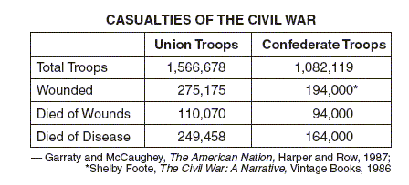

38) Which statement is best supported by the data in the table?
- The Confederate troops lost the War because of more injuries and fatalities.
- The Union army had better generals during the Civil War.
- The Civil War had more casualties than any other war.
- More soldiers died from disease than from wounds.

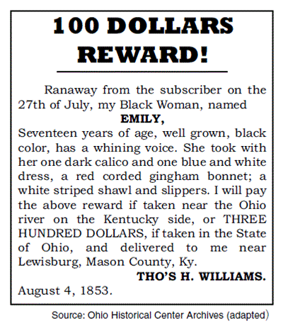
39) Prior to the Civil War, abolitionists reacted to the situation described in the poster by

- supporting the Underground Railroad.
- opposing the Emancipation Proclamation.
- banning freed slaves from Northern states.
- proposing a stricter fugitive slave law.

"Although important strides were made, Reconstruction failed to provide lasting guarantees of the civil rights of the freedmen.”

40) Which evidence best supports this statement?
- passage of Jim Crow laws in the latter part of the 19th century
- ratification of the 13th, 14th, and 15th amendments
- refusal of Southern States to allow sharecropping
- passage of the Civil Rights Acts of 1866

"No state [shall] deprive any person of life, liberty, or property, without due process of law; nor deny to any person within its jurisdiction the equal protection of the laws."
-14th Amendment to the Constitution of the United States

41) A direct result of this amendment was that
- the process of amending the Constitution became slower and more complex
- the guarantees in the Bill of Rights were applied to state actions
- every citizen gained an absolute right to freedom of speech and assembly
- the power of the Federal Government was sharply reduced

42) Abraham Lincoln believed that the Northern States should…
- punish citizens of the Southern States for starting the Civil War.
- force the South to pay the Federal Government for the war’s costs.
- allow the Southern States to reenter the nation as quickly as possible.
- establish the Republican Party as the only political party in the South.

43) President Abraham Lincoln argued against the secession of the Southern States based on the fact that…
- slavery was immoral and not profitable.
- the government was a union of people and not of states.
- the southern states did not permit their people to vote on secession.
- his duty as president to defend the United States against foreign invasion.

44) As a result of the Civil War…
- states were legally allowed to secede from the Union.
- Congress passed an amendment outlawing secession.
- the power of the central government was strengthened.
- the power of the judiciary was severely diminished.

45) Slavery officially came to end in the United States with the passage of the…
- Compromise of 1850.
- Emancipation Proclamation of 1863.
- Thirteenth Amendment in 1865.
- Civil Rights Act of 1964.
“By the 1850’s the Constitution, originally framed as an instrument of national unity, had become a source of sectional discord.”

46) The quote suggests that
- Vast differences of opinion existed over the issue of state rights
- The Federal government had become more interested in foreign affairs than in domestic problems
- The constitution had no provisions for governing new territories
- The southern States continued to import slaves

47) This event changed the geographic landscape of the United States
- The Manifest Destiny
- The Indian Removal Act
- The Trail of Tears
- The Louisiana Purchase

48) Which of the following events resulted in the deaths of thousands of Native Americans?
- The Indian Removal Act
- The Trail of Tears
- The Battle of the Alamo
- The creation of the Oregon Trail

