Wake County Public School System
Social Studies Benchmark
Grade 8

Units 7 – 9

Grade 8 Benchmark: Units 7 - 9

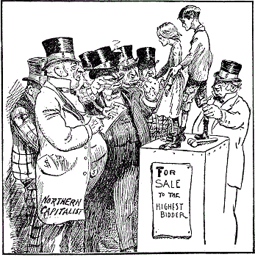
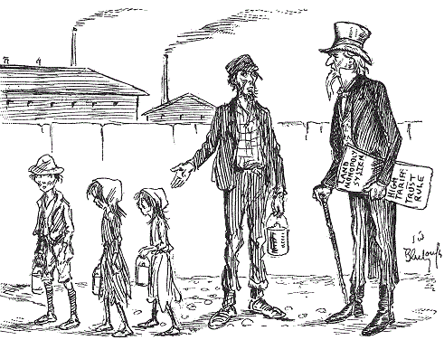

- What is the message from the cartoon (featuring a father and his three children) on the left?
  - Children went to work because they wanted a job.
  - Children went to work because they hated school.
  - Children went to work to make their parents rich.
  - Children went to work to help their family survive.

- What is the message from the cartoon on the right?
  - Children were treated similar to slaves.
  - Children were not needed to work in the factories.
  - Children had more rights than slaves.
  - Children had more power than most workers.

- What can these cartoons tell the reader about child labor?
  - Children liked working in the factories.
  - Children were not needed to work in factories.
  - Children made up a significant part of the workforce.
  - Children made it harder for factories to run.

- Who does the man with the cane, in the cartoon on the left, represent?
  - A grandfather
  - A concerned citizen
  - The government
  - The police

US Recognition of Cuban Independence

Whereas, the abhorrent conditions which have existed for more than three years in the Island of Cuba, so near our own borders, have shocked the moral sense of the people of the United States, have been a disgrace to Christian civilization, culminating, as they have, in the destruction of a United States battleship, with two hundred and sixty-six of its officers and crew…Therefore, Resolved, by the Senate and House of Representatives…

First. That the people of the Island of Cuba are, and of right ought to be, free and independent.

Second. That it is the duty of the United States to demand, and the Government of the United States does hereby demand, that the Government of Spain at once relinquish its authority and government in the Island of Cuba, and withdraw its land and naval forces from Cuba and Cuban waters.

Third. That the President of the United States be, and he hereby is, directed and empowered to use the entire land and naval forces of the United States, and to call into the actual service of the United States, the militia of the several States, to such extent as may be necessary to carry these resolutions into effect.

Fourth. That the United States hereby disclaims any… intention to exercise sovereignty, jurisdiction, or control over said Islands except for the pacification thereof, and asserts its determination, when that is accomplished, to leave the government and control of the Island to its people. Approved, April 20, 1898.

- What event occurred that caused the President to finally take action against Spain?
- Destruction of a battleship
- Terrible conditions in Cuba
- Beginning of World War I
- Blockade of Havana Harbor

- What was the United States demanding from Spain?
- Give Spain full use of Cuba’s harbor.
- Give Cuba its freedom from Spain.
- Give the United States independence from Cuba.
- Give Cuba the full use of Spain’s navy.

- How was the United States going to help Cuba?
- Use the Harbor of Havana for commerce.
- Use the US military to help keep them free.
- Take total control of the Cuban government.
- Take Spain’s naval and armed forces apart.

- Which of the following is the best definition of “abhorrent “as it is used in the first line of the text?
- Hopeful
- Fearful
- Questionable
- Repulsive
Excerpt from “Enactments So Utterly Un-American” by Constance Gordon-Cumming

“The month of May 1881 was marked by the most extraordinary anomaly which could possibly have arisen, among a people whose national existence is based on the Declaration of Independence, and the assumption of liberty and equality of all men, without distinction of race or colour.

This extraordinary event was nothing less than that the American Legislature should have yielded to the clamours of the low Irish in California, and to their ceaseless anti-Chinese howl, to the extent of actually passing a law prohibiting all Chinese immigration for the next ten years, beginning from ninety days after the passing of the Act, heavy penalties being inflicted on any Shipmaster who shall land any Chinaman of the labouring class at any port in the Land of Freedom.”

- Based on the excerpt, what was the purpose of the specified act?
- To mark an extraordinary anomaly to ever arise in the Legislature and base all future laws on the Declaration of Independence.
- To prohibit the immigration of Chinese laborers to the United States for the next ten years and punish shipmasters who allow their passage.
- To prevent the immigration of shipmasters from the United States to China in response to harsh restrictions and penalties.
- To guarantee liberty and equality to all men, without distinction of race or color, as soon as they become American citizens.

- According to Gordon-Cumming, why did the legislature enact a law prohibiting Chinese immigration?
- Out of response to constant complaints from other people living in California.
- Out of fear that many jobs would be shipped to other countries, like China.
- Out of concern for the immigrant population that was rising at a high rate.
- Out of laziness and a lack of desire to properly handle immigration concerns.

- Why does the author call the new law “utterly un-American”?
- She does not think that the law shares the same ideals of liberty and equality outlined in the Declaration of Independence.
- She does not understand why the Legislature did not respond to the demands of the citizens it was created to represent.
- She does not think it is fair for shipmasters to be punished for bringing immigrants to the American ports.
- She does not think it is very “American” to enact specific laws that will only be valid for ten years following their creation.

- What is the purpose of pointing out that opponents to Chinese immigration were the “low Irish in California”?
- To remind the reader that Americans from both coasts were opposed to Chinese immigration.
- To remind the reader that many of the opponents also immigrated to the United States at one point in time.
- To remind the reader of the tensions that existed between citizens of Irish and Chinese backgrounds.
- To remind the reader of the diversity of citizens living in California at the time the Act was passed.

- Based on her tone of disgust and frustration about the “un-American” nature of the law, which other historical movement might the author consider to be “un-American”?
- Women’s suffrage (right to vote)
- Slavery
- Civil Rights
- All of the above

- The act referred to in the above excerpt also included the “Section 6 exempt status for teachers, students, merchants, and travelers” allowing people in these classes to enter the United States with the proper documentation. What does this exemption imply about American values at the time of its enactment?
- Vacation and travel were highly valued by those in the Legislature.
- Law makers valued immigrants, as long as they were not educated or wealthy.
- Education and economic activity motivated legislation at the time.
- Hard work and perseverance were held in high regard by all citizens.

Excerpt of Woodrow Wilson’s speech to Congress where he introduced his Fourteen Points plan:
“We entered this war because violations of right had occurred which touched us to the quick and made the life of our own people impossible unless they were corrected and the world secured once for all against their recurrence. What we demand in this war, therefore, is nothing peculiar to ourselves.
It is that the world be made fit and safe to live in; and particularly that it be made safe for every peace-loving nation which, like our own, wishes to live its own life, determine its own institutions, be assured of justice and fair dealing by the other peoples of the world as against force and selfish aggression. All the peoples of the world are in effect partners in this interest, and for our own part we see very clearly that unless justice be done to others it will not be done to us. The program of the world's peace, therefore, is our program…”

Excerpt from the speech given by Henry Cabot Lodge, former Republican politician and Senate Majority Leader, in Washington D.C. on 12 August 1919 in which he set forth his objections to the League of Nations:
“No doubt many excellent and patriotic people see a coming fulfillment of noble ideals in the words 'league for peace.' We all respect and share these aspirations and desires, but some of us see no hope, but rather defeat, for them in this murky covenant. For we, too, have our ideals, even if we differ from those who have tried to establish a monopoly of idealism.
Our first ideal is our country… she has great problems of her own to solve, very grim and perilous problems, and a right solution, if we can attain to it, would largely benefit mankind.”

- According to Wilson, why did the United States enter WWI?
- To secure life and freedom for all of the people in the world.
- To secure life and freedom for all of the people in Europe.
- To secure life and freedom for all of the people in the United States.
- To secure life and freedom for all of the people in the military.

- Which phrase from Wilson’s speech best supports the creation on the League of Nations?
- “The program of the world's peace, therefore, is our program.”
- “All the peoples of the world are in effect partners in this interest.”
- “Violations of right had occurred which touched us to the quick.”
- “We all respect and share these aspirations and desires.”

- According to Cabot Lodge, what is the best way for the US to ensure world peace?
- By establishing a monopoly of idealism.
- By blocking the desires of the murky covenant.
- By focusing on solving its own problems first.
- By respecting the desires of other nations.
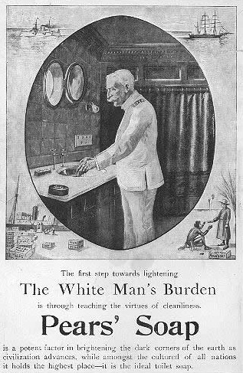

The White Man’s Burden

This famous poem, written in 1899 by Britain’s imperial poet Rudyard Kipling, was a response to the American takeover of the Philippines after the Spanish-American War.

Take up the White Man's burden--
Send forth the best ye breed--
Go bind your sons to exile
To serve your captives' need;
To wait in heavy harness,
On fluttered folk and wild--
Your new-caught, sullen peoples,
Half-devil and half-child.

Text from Advertisement
The first step towards lightening
The White Man’s Burden
is through teaching the virtues of cleanliness.
Pears’ Soap
Is a potent factor in brightening the dark corners of the earth as civilization advances, while amongst the cultured of all nations it holds the highest place – it is the ideal toilet soap.

- Both the advertisement and the poem express the prevailing attitude in 1899 that
  - it was the responsibility of Americans and the British to “civilize” native peoples.
  - it was the right of Americans and the British to take what they needed from the rest of the world.
  - it was the right of Americans and the British to use native peoples as slaves.
  - it was the responsibility of Americans and the British to oppose their governments’ treatment of native peoples.

- Both the advertisement and the poem are examples of
  - anti-semitism, the belief in the inferiority of the Jews.
  - racism, the belief in the superiority of one race over another.
  - classism, the belief in the superiority of the rich over the poor.
  - egalitarianism, the belief in human equality.
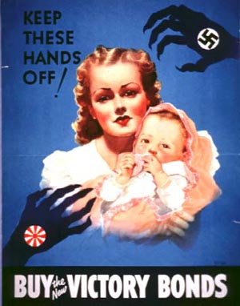

Symbol of Nazi Germany

Symbol of Japan

- What emotions was the artist appealing to when he put the symbols of Japan and the Nazi party on the shadowy hands on the poster?
- fear and urgency
- sorrow and anger
- hunger and pain
- regret and exhaustion

- What is the purpose of this propaganda poster?
- To convince citizens that wasting their money on unnecessary luxuries puts them in danger.
- To convince citizens that buying war bonds will help protect them from enemy forces.
- To convince citizens that buying war bonds will keep Nazi forces from stealing their belongings.
- To convince citizens to become soldiers and fight in WWII in order to protect their families.

- How does the poster depict America’s enemies?
- As liberators of women and children.
- As threats to innocent civilians.
- As strong military opponents.
- As opponents that will be easy to defeat.

"The Red Army and Navy and the whole Soviet people must fight for every inch of Soviet soil, fight to the last drop of blood for our towns and villages...onward, to victory!"
- Joseph Stalin (after Nazi Germany attacked the Soviet Union) - July, 1941

“As Commander-in-Chief of the Army and Navy I have directed that all measures be taken for our defense, that always will our whole nation remember the character of the onslaught against us. No matter how long it may take us to overcome this premeditated invasion, the American people, in their righteous might, will win through to absolute victory. I believe that I interpret the will of the Congress and of the people when I assert that we will not only defend ourselves to the uttermost but will make it very certain that this form of treachery shall never again endanger us. Hostilities exist. There is no blinking at the fact that our people, our territory and our interests are in grave danger. With confidence in our armed forces, with the unbounding determination of our people, we will gain the inevitable triumph. So help us God. I ask that the Congress declare that since the unprovoked and dastardly attack by Japan on Sunday, December 7, 1941, a state of war has existed between the United States and the Japanese Empire.”
- Franklin D. Roosevelt (after the Japanese bombed Pearl Harbor) - December 8, 1941

- Why did President Roosevelt include the phrase “premeditated invasion,” meaning it was planned in advance, to describe Japan’s attack?
- To show that the U.S. government knew the Japanese were going to attack.
- To show the similarities between the Japanese military and the Nazi soldiers.
- To remind U.S. citizens how devastating the attack was for the country.
- To convince citizens and Congress that the Japanese meant to start a war.

- What is Roosevelt’s purpose for including the first line of the excerpt?
- To ensure the American people that he has taken measures to protect the country.
- To encourage people to join the military and fight against the Japanese attackers.
- To thank the American people for electing him and allowing him to serve them.
- To show the Japanese military how quickly Americans recover from attacks.

- According to Roosevelt, why should Congress declare war on Japan?
- Japan and the US are already in a state of war after the attack on Pearl Harbor.
- The US must declare war on Japan to prevent them from attacking again.
- Declaring war on Japan might help boost the US economy like it did during WWI.
- The Japanese empire threatened to attack US allies if war was declared.

- Select the answer choice that places the following four events in the correct order.
- WWII Begins in Europe
- FDR gives the above speech
- Congress declares war on Japan
- The Japanese bomb Pearl Harbor

- A, B, C, D
- A, D, B, C
- D, C, A, B
- D, B, A, C
Politician
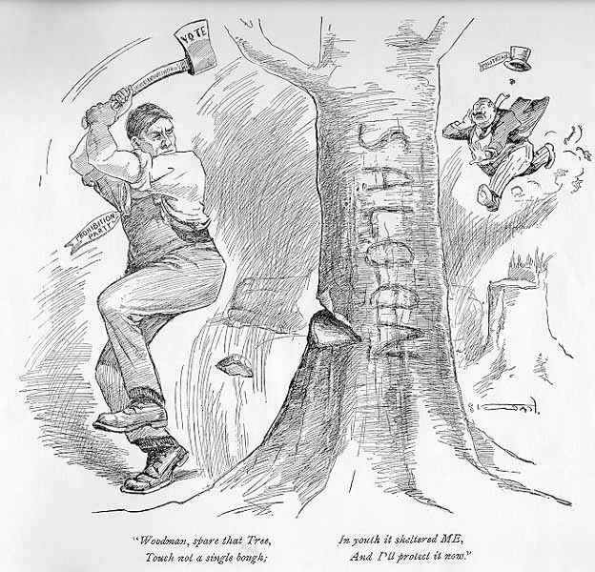

Saloon = Bar

Prohibition Party

“Woodsman, spare that Tree, Touch not a single bough (branch);
In youth it sheltered ME, And I’ll protect it now.”

You ought to get a good deal out of this cartoon, for it is more true than lots of the preaching you hear. It is the axe at the root of the tree that does business. Nothing else counts.
Neither the politician nor the liquor traffic itself cares a copper about the gentle pruning process which lots of good people are constantly employing towards the saloon and its allies.
The fact is that cutting off an occasional twig does not hurt the tree. In fact, it may strengthen some of its evil branches, and make them all the more vigorous, while the tree itself offers a more cooling shade to the politicians and boodlers who gather under it.
The only thing that will chop down the tree, and cause it to forever cease from troubling, is a Prohibition axe. But the axe itself will not chop. It must therefore be wielded by an individual Prohibitionist at the ballot-box, and a Prohibition party in the Legislature, and the executive branch of Government.
Let the politician sing his little ditty about sparing the tree. Your business as a citizen is to “put in the whacks” and thus help to bring the tree to the ground.

- What was the illegalization of alcohol called?
- Prohibition
- Inhibition
- Secession
- Consumption

- Looking at the cartoon, what is the man on the right trying to eliminate?
- Politicians
- The prohibition movement
- Places that sold alcohol
- Women’s right to vote.

- According to the source, what must happen to totally get rid of liquor?
- Close small saloons
- Vote to make Prohibition the law
- Pay politicians to close all saloons
- Make all liquor legal

- Why is the source stating the cartoon is “more true” than what people are hearing?
- Saloons are the root of all the problems.
- Politicians are lying about the issue.
- Big business creates issues with saloons.
- Prohibition causes problems.

Answer Key
- D 8.E.1.3
- A 8.E.1.3
- C 8.E.1.3
- C 8.H.3.2
- A 8.H.1.3
- B 8.H.3.3
- B 8.H.3.3
- D 8.H.3.3
- B 8.H.1.2
- A 8.H.1.3
- A 8.C&G.1.1
- B 8.C&G.1.3
- B 8.C&G.1.3
- C 8.C&G.1.4
- A 8.H.1.3
- B 8.H.2.1
- C 8.C&G.1.1
- A 8.H.2.1
- B 8.H.2.1
- A 8.H.1.3
- B 8.E.1.3
- B 8.C&G.1.1
- D 8.H.1.3
- A 8.H.2.2
- A 8.H.1.2
- C 8.H.1.1
- A 8.H.3.2
- B 8.H.2.3
- B 8.H.3.2
- B 8.E.1.3

